

Massachusetts
School-to-College Report
High School Class of 2005

February 2008

This report was produced in part with the financial support of the National Governors Association and the Nellie Mae Education Foundation.

February 2008

Dear Colleagues:

It is with great pride that we present the first Massachusetts School-to-College Report, the result of collaboration between the Massachusetts Board of Higher Education and the Massachusetts Department of Education.

This report provides detailed information on how Massachusetts public high school graduates perform in the Commonwealth’s public colleges and universities. With these data, for the first time, we will be able to answer such important questions as:

- How many public high school graduates enroll in public colleges and which institutions do they attend?
- How do enrollment patterns and college outcomes differ for subgroups of students, such as low-income students?
- How many public high school graduates enroll in developmental courses in college and in what subjects?
- How many public high school graduates reenroll for a second year of college?
- How many credits, on average, do public high school graduates earn in their first year of college and what is their first-year college GPA?

We hope that the results of the School-to-College Report serve as a catalyst for discussion and action—statewide, within regions, and at high schools—about the academic preparation and performance of the Commonwealth’s public school students. Ultimately, this dialogue should help us reach our goal of college and career readiness and success for every student in Massachusetts.

Patricia Plummer  Chancellor  Board of Higher Education | Jeffrey Nellhaus  Acting Commissioner  Department of Education

Massachusetts School-to-College Report
High School Class of 2005

Table of Contents

Executive Summary ii
A. Fall 2005 College Enrollment of the 2005 School-to-College Cohort 1
B. Cohort Characteristics 2
C. Academic Preparation 4
D. Fall 2005 Enrollment in Developmental Coursework 5
E. College Outcomes 7
F. Enrollment by Institution 10
Appendix A: Background and Methodology 11
Appendix B: Data Notes 12

For further information about the data contained in this report or questions concerning the School-to-College Report, please contact:

- Massachusetts Board of Higher Education, One Ashburton Place, Room 1401, Boston, MA 02108 http://www.mass.edu, 617-994-6950.
- Massachusetts Department of Education, 350 Main Street, Malden, MA, 02148 http://www.doe.mass.edu, 781-338-3108.

This report can be found at http://www.doe.mass.edu/research/reports/research.html and
http://www.mass.edu/reports.

Massachusetts School-to-College Report
High School Class of 2005

Executive Summary
Postsecondary education and training is a necessity in today’s new economy. Jobs—even entry-level positions—demand ever-increasing levels of skill and knowledge. By 2010, jobs requiring some postsecondary education will make up more than two-thirds of new jobs in the United States. Because the economy has shifted, education faces new challenges and more high school graduates will need to be college-ready.
The School-to-College Report is drawn from a new database that links public K–12 and higher education data, making it possible to report in detail how Massachusetts public high school students are performing in the Commonwealth’s public postsecondary institutions. The report’s findings will help educators and policymakers develop sound policies and practices for increased college readiness for all students. College readiness is generally understood as a student’s ability to successfully complete first-year college-level courses without needing developmental (remedial) coursework.
The inaugural 2005 report covers information on students who graduated or obtained a certificate of attainment from a Massachusetts public high school in spring 2005 and enrolled in a Massachusetts public postsecondary institution in fall 2005. In addition to this overall state report, each high school in the Commonwealth enrolling ten or more students in Massachusetts public postsecondary institutions will receive a detailed report outlining their graduates’ performance in higher education.
Key findings
- Among the public high school class of 2005, more than 19,000 students (33 percent) enrolled in a Massachusetts public postsecondary institution in fall 2005.
- Of these students, 45 percent enrolled at a community college, 25 percent at a state college, and 30 percent at a state university campus.
- African American, Hispanic, low-income and limited English proficient students and students receiving special education services in high school were more likely to enroll at a community college. Asians were more likely to enroll at a state university campus.
- Public high school graduates who enrolled as first-time, full-time degree seeking students completed an average of 26.1 credits and earned an average GPA of 2.7 in their first year in college.
- More than 80 percent of first-time, full-time degree seeking students reenrolled for a second year of college in fall 2006.
- Among public high school graduates, 37 percent enrolled in at least one developmental (remedial) course in their first semester in college.
- Of students enrolled at community colleges, 65 percent enrolled in at least one developmental course, versus 22 percent at state colleges and 8 percent at state university campuses.
- Remediation rates were higher for some student groups:
  - 63 percent of students receiving special education services in high school
  - 59 percent of African Americans
  - 58 percent of Hispanics
  - 52 percent of low-income students
  - 50 percent of limited English proficient students
- Among students who passed the 10th grade Mathematics MCAS test at the needs improvement level, 50 percent enrolled in developmental math, as opposed to 20 percent of students who passed at the proficient level and 4 percent at the advanced level.
Overall the 2005 high school graduate cohort is making progress in higher education (more than 80% persist beyond the first year), but the data shows that too many students required remediation. Thirty-seven percent of the 2005 cohort—more than 7,000 public high school graduates—enrolled in at least one developmental course in the fall of 2005. Remediation, which does not count towards degree attainment, is costly. For students, it leads to increased time to graduation, higher educational expenses, and an increased likelihood of dropping out of college. Because African American, Hispanic, low income, limited English proficient, and students who received special education services in high school were more likely to enroll in developmental courses, these subgroups of students are also disproportionately affected by the high costs of remediation. The differences in developmental education rates mirror the achievement gaps apparent as early as elementary school, underscoring the fact that college readiness is an issue across all levels of education.
Community colleges enroll the greatest number of students who require remediation, demonstrating their unique role in preparing high school graduates for entry-level college courses and their critical position as a point of access to higher education. In recent years, many community colleges and high schools in Massachusetts have partnered to foster college readiness through college planning, dual enrollment, and early assessment activities in recognition of the fact that high schools, school districts and postsecondary institutions all have a stake in the improvement of the college readiness of high school graduates.
The findings of the School-to-College Report suggest that more needs to be done to prepare all public high school graduates for college. The Massachusetts Board of Higher Education and the Department of Education are committed to supporting policies, practices, and initiatives that will boost the number of students who graduate from high school college-ready. This Report should serve as a catalyst for K–12 and higher education partners to further align high school and college expectations and curriculum and to work together to provide every student with the foundation needed for college success.
Massachusetts School-to-College Report
High School Class of 2005
The data presented below includes information on Massachusetts public high school graduates who enrolled at a Massachusetts public postsecondary educational institution. These students will be referred to as the 2005 school-to-college cohort. For definitions of terms used throughout the report, see Appendix B.

Fall 2005 College Enrollment of the 2005 School-to-College Cohort
Finding:
- One-third of 2005 public high school graduates enrolled in Massachusetts public postsecondary educational institutions in fall 2005.
Fall 2005 Public Enrollment of 2005 Public High School Graduates
Fall 2005 Public Postsecondary Enrollment of 2005 Public High School Graduates by Segment
Finding:
- The largest proportion of students enrolled at a community college.
Fall 2005 Public Postsecondary Enrollment of the 2005 School-to-College Cohort by Segment
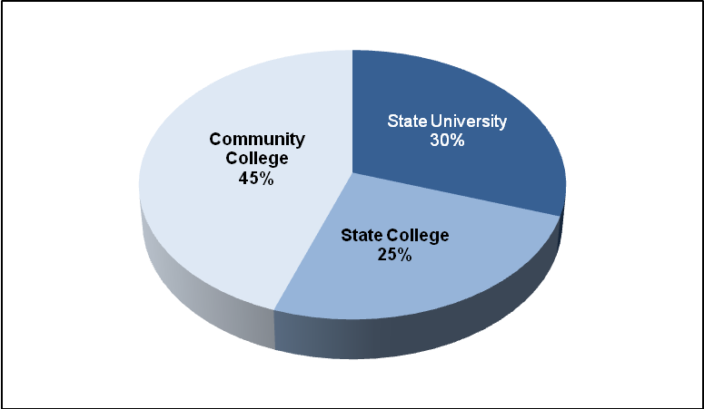

Characteristics of the 2005 School-to-College Cohort
Finding:
- African American and Hispanic public high school graduates are more likely to enroll at community college than the cohort as a whole.
Public Postsecondary Enrollment by Race/Ethnicity

Public Postsecondary Enrollment by Race/Ethnicity and Segment

Finding:
- Of the 2005 cohort, 10,261 students were female and 9,217 were male. There are slight differences between female and male enrollment by segment.
Public Postsecondary Segmental Enrollment by Gender
Finding:
- Students who received special education services or who were identified as limited English proficient (LEP) or low income in high school were more likely to enroll at community colleges than the cohort as a whole.
Public Postsecondary Enrollment by Special Population

Public Postsecondary Enrollment by Special Population and Segment
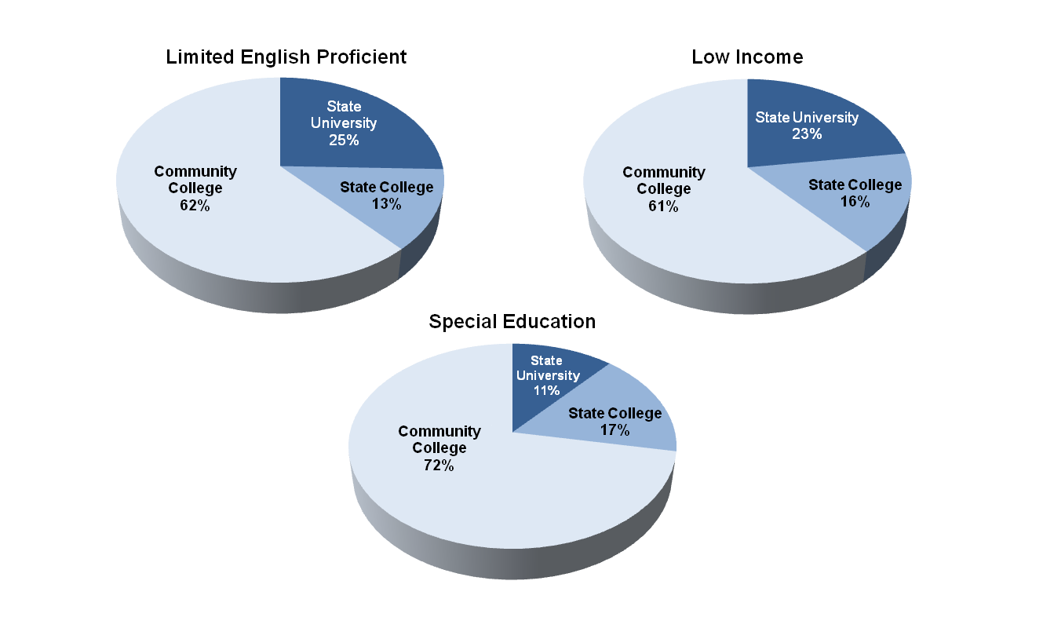

C. Academic Preparation of the 2005 School-to-College Cohort
Findings:
- High school graduates who scored advanced on the mathematics or English language arts (ELA) 10th grade MCAS test were more likely to enroll at a state university campus, whereas graduates who scored needs improvement were more likely to attend community college.
- High school graduates who scored proficient tended to be evenly distributed among segments.
Public Postsecondary Enrollment by 10th Grade MCAS Performance Level and Segment
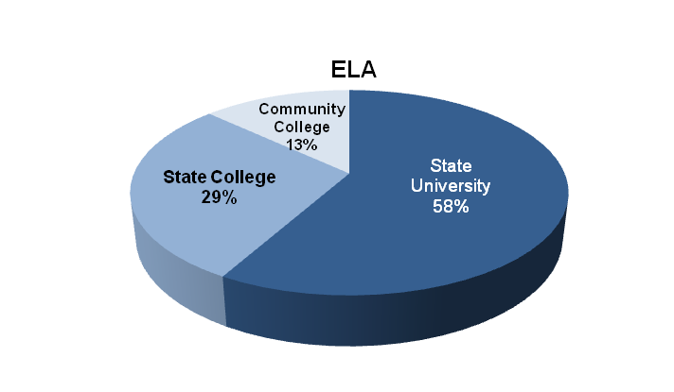  Students Scoring Advanced  Students Scoring Proficient | 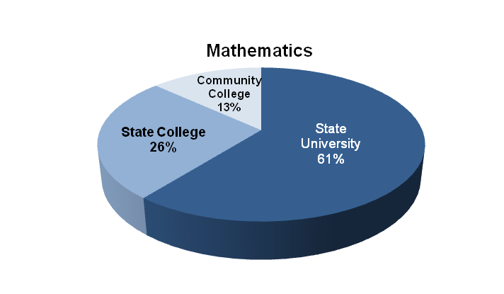
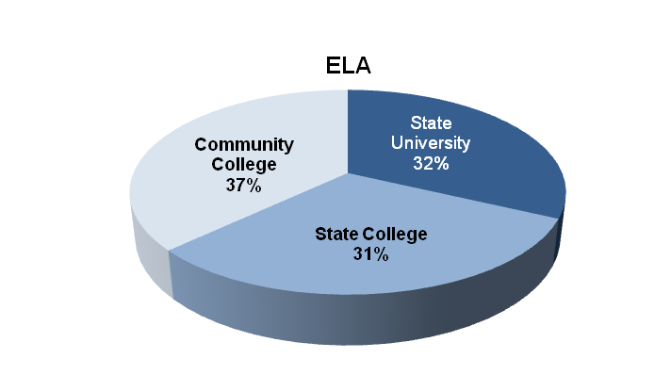  Students Scoring Needs Improvement | 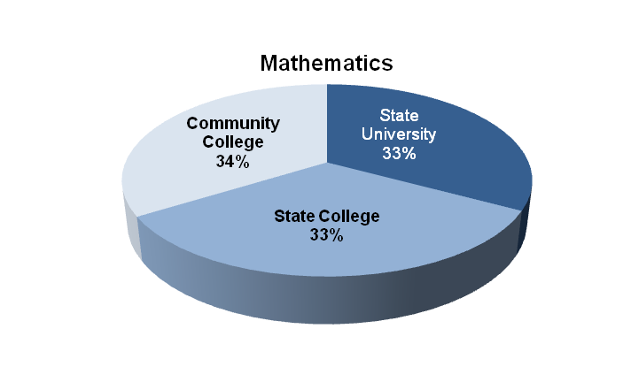
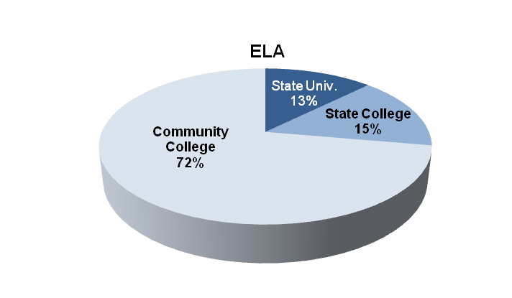 | 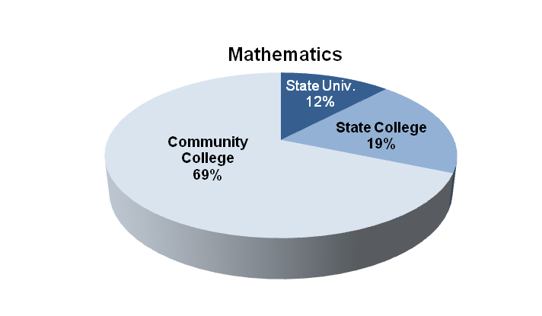

D. Fall 2005 Enrollment in Developmental Coursework of the 2005 School-to-College Cohort
Finding:
- Thirty-seven percent of the 2005 school-to-college cohort enrolled in one or more developmental subjects during the fall of 2005.
Public Postsecondary Enrollment in Developmental Coursework First Semester
Finding:
- Twenty-nine percent of the 2005 school-to-college cohort enrolled in developmental math during the fall of 2005.
Public Postsecondary Enrollment in Developmental Coursework by Subject
Finding:
- Community college students are most likely to enroll in developmental coursework.
Public Postsecondary Enrollment in Developmental Coursework by Segment
Finding:
- A greater percentage of African American and Hispanic students enrolled in developmental courses during their first semester compared to the cohort as a whole.
Public Postsecondary Enrollment in Developmental Coursework by Race/Ethnicity
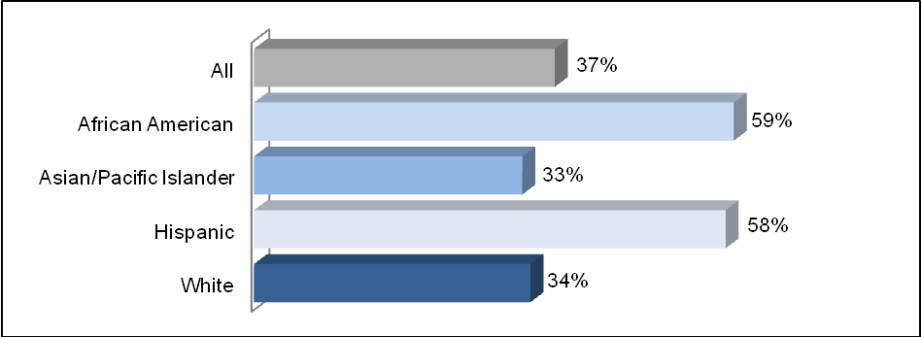
Finding:
- Students who received special education services or who were identified as LEP or low income in high school were more likely to enroll in a developmental course during their first semester.
Public Postsecondary Enrollment in Developmental Coursework by Special Population
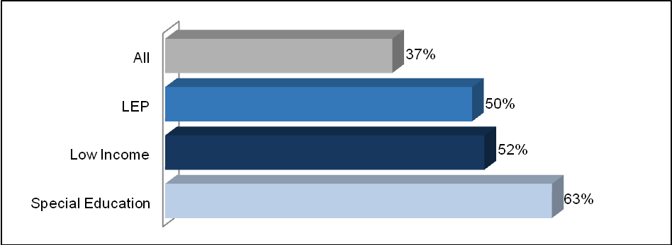

Finding:
- Students who scored needs improvement on the 10thgrade mathematics or English language arts (ELA) MCAS test were more likely to enroll in a developmental course than students who scored proficient or advanced.
Public Postsecondary Enrollment in Developmental Math by 10th Grade Mathematics MCAS Test Performance

Public Postsecondary Enrollment in Developmental Reading by 10th Grade ELA MCAS Test Performance

E. College Outcomes for the 2005 School-to-College Cohort
Finding:
- Approximately 90 percent of the 19,478 new students in the 2005 school-to-college cohort enrolled as first-time, full-time, degree-seeking students.
Public Postsecondary Enrollment of First-time, Full-time, Degree-seeking Students in Fall 2005
Findings:
- Of the 2005 high school graduates who enrolled as first-time, full-time, degree-seeking students in fall 2005, more than 80 percent remained enrolled in higher education in fall 2006.
- Persistence rates were highest for students who initially enrolled at a state university.
First-to-Second Year Persistence Rate by Segment of Initial Postsecondary Institution
Finding:
- Hispanic and African American students have lower persistence rates than the cohort as a whole.
Persistence Rate by Race/Ethnicity
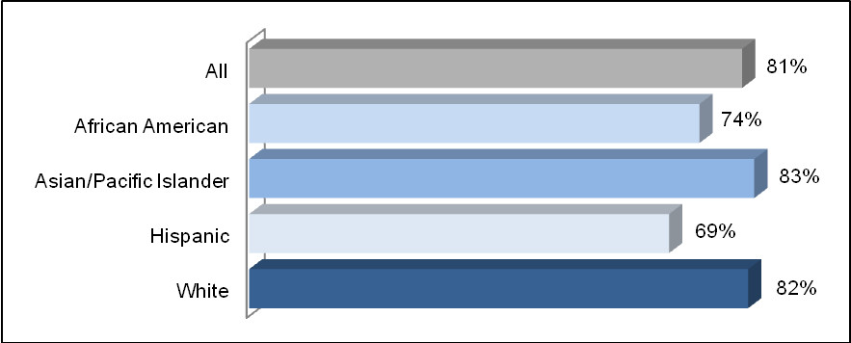
Finding:
- Students identified as low income and those who received special education services in high school have lower persistence rates than the cohort as a whole.
Persistence Rate by Special Population
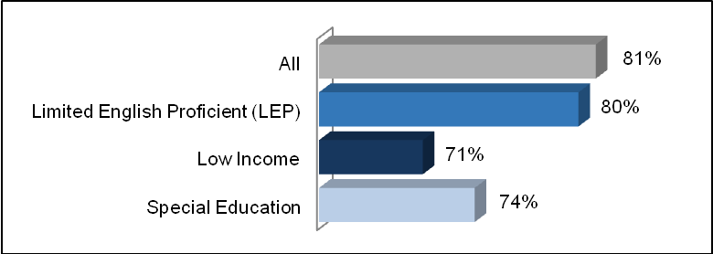
Finding:
- The overall average college GPA earned during the first year was 2.7 for all graduates of public high schools who enrolled as full-time students in fall 2005.
Average First-Year College GPA by Race/Ethnicity and Special Population
Finding:
- The overall average college credits earned during the first year was 26.1 for all graduates of public high schools who enrolled as full-time students in fall 2005.
Average First-Year College Credits by Race/Ethnicity and Special Population

F. Enrollment by Institution of the 2005 School-to-College Cohort
Findings:
- The University of Massachusetts Amherst was the most common public postsecondary destination of the 2005 high school graduating class.
- In general, the institutions with largest enrollment of 2005 public high school graduates were the larger public colleges and universities.
Public Postsecondary Enrollment by Institution

Appendix A: Background and Methodology

About the Data
Students who graduated or obtained a certificate of attainment from a Massachusetts public high school and enrolled in a Massachusetts public postsecondary institution are included in the School-to-college Database. The current School-to-College Report contains information on those students who graduated high school in 2005 and enrolled in college in the fall of 2005, referred to as the 2005 school-to-college cohort. This group represents approximately one-third of public high school graduates in the state of Massachusetts in 2005.

Special Considerations
- Students who attended private Massachusetts high schools and students who attended a Massachusetts public high school and enrolled in a private or out-of-state postsecondary institution are not included in this report.

- The Board of Higher Education and the Department of Education student records were matched on multiple identifiers such as first and last name, date of birth, high school of graduation, and graduation year. Only those records that matched across both data sets were included in the final database. Student data confidentiality was maintained during the construction of the database.

- Some data are only available for those students enrolled in a state college or a state university campus and not a community college. Since community colleges have an open enrollment policy, they are not required to collect information on applicants’ high school performance, such as high school GPA or SAT score.

- A full-year postsecondary cycle must be completed in order to report data on postsecondary outcomes. Future reports will generally be delivered in the spring approximately two years after the cohort’s high school graduation.

Appendix B: Data Notes

- Public College Enrollment of Public High School Graduates
The number of graduates who went on to public postsecondary education in fall 2005 includes the number of public high school graduates who enrolled as new students in public postsecondary institutions in Massachusetts. New students are defined as those who had never registered at their current higher education institution prior to 2005.
Postsecondary data include measures for new students and first-time, full-time, degree-seeking students. The definition of new students is more inclusive than the latter. It includes all new students, whether enrolled full-time or part-time and whether degree-seeking or enrolled in a non-degree program.
Segment refers to the category of public institution attended: community college, state college, or state university.
- Characteristics of the Class of 2005
All data pertain to new students as defined in Section A. Student characteristics include:
- Race/Ethnicity: Racial/ethnic category as recorded in high school.
- Gender: Gender as recorded in high school.
- Limited English Proficient: Ever identified as limited English proficient while in high school.
- Low Income: Eligible for free or reduced-price meal services under the National School Lunch and School Breakfast programs in twelfth grade.
- Special Education: Ever received special education services during high school.
- Academic Preparation of the Class of 2005
All data pertain to new students as defined in Section A.
MCAS scores represent graduates’ highest level of achievement on the tests.
- Enrollment of the Class of 2005 in Developmental Coursework
All the data in Section D pertain to new students as defined in Section A.
Developmental courses are designed to prepare students for college-level work and do not count toward a degree. Students generally enroll in these courses based on their performance on placement exams.
Students who were enrolled in at least one developmental course in the fall semester were counted as “enrolled in any developmental coursework.” Note that developmental courses may cover a single subject or multiple subjects and may meet for the full term or less.
Tables showing enrollment in developmental coursework by MCAS performance level are based on highest MCAS performance level.

- College Outcomes for the Class of 2005
All the data in Section E pertain to first-time, full-time, degree-seeking students.
These data exclude new students who are non-degree-seeking or enrolled less than full-time. Most institutions define full-time as carrying a load of 12 to 15 credits. Students who earned a degree or certificate within one year, and therefore would not be expected to reenroll, are excluded from the outcomes analysis.
Persistence, also called retention, refers to students who enroll one fall and return the next fall to continue their college studies. The figures in these tables include students who began their studies at a Massachusetts public postsecondary institution and continued at either the same institution or another public or private institution, either in Massachusetts or out-of-state. The Board of Higher Education contracts with the National Student Clearinghouse to track students who enroll at public postsecondary institutions in Massachusetts and then leave to enroll at another institution of higher education, including private and out-of-state institutions.
Persistence by segment measures the percentage of students who returned to college for a second year by the postsecondary segment of their initial institution: community college, state college, or state university.
Average college GPA is reported for students who persisted at their original postsecondary institution and reflects the GPA earned during the first year. Data on transfer students are not included. A cumulative grade point average of 2.0 is equivalent to a C, while a 3.0 is a B and a 4.0 is an A.
Average credits earned are reported for students who persisted at their original postsecondary institution and reflect credits earned during the first year. A typical full-time student carries a credit load of 12 to 15 credits per semester.
- Enrollment by Institution
These data show the institutions of enrollment of new students, as defined in Section A. The 28 public postsecondary institutions in Massachusetts represented in this report are listed below. The University of Massachusetts Medical School in Worcester is not included in this listing because the medical school only enrolls graduate students.
Community Colleges (CC)
Berkshire CC, Bristol CC, Bunker Hill CC, Cape Cod CC, Greenfield CC, Holyoke CC,
Massachusetts Bay CC, Massasoit CC, Middlesex CC, Mount Wachusett CC,
North Shore CC, Northern Essex CC, Quinsigamond CC, Roxbury CC,
Springfield Technical CC
State Colleges (SC)
Bridgewater SC, Fitchburg SC, Framingham SC, Massachusetts College of Art and Design,
Massachusetts College of Liberal Arts, Massachusetts Maritime Academy, Salem SC,
Westfield SC, Worcester SC
State University Campuses
University of Massachusetts Amherst, University of Massachusetts Boston,
University of Massachusetts Dartmouth, University of Massachusetts Lowell

Carnevale, Anthony P. and Donna M. Desrochers, Standards for What? The Economic Roots of K–16 Reform, Educational Testing Service, 2003
Segment refers to the category of public institution attended: community college, state college or state university.
Persistence rate is the percentage of first-time, full-time, degree-seeking students who enroll one fall and reenroll the following fall, whether at the initial institution of enrollment or any other postsecondary institution.
A typical full-time student carries a credit load of 12 to15 credits per semester.
The state higher education system includes 29 campuses: 5 university campuses, 9 state colleges, and 15 community colleges. This report does not include information on the University of Massachusetts Medical School in Worcester, which enrolls only graduate students.

